# **PRACTICE REPORT**

# **WEB PROGRAMMING LAB WORKS**

# **MODULE 10**

# **“JSON (JavaScript Object Notation)”**



**Assembled by:**

# **ONIC AGUSTINO**

# **L200234275**

**X**

**PROGRAM STUDI TEKNIK INFORMATIKA**

**FAKULTAS KOMUNIKASI DAN INFORMATIKA**

**UNIVERSITAS MUHAMMADIYAH SURAKARTA**

**TAHUN 2024/2025**

**PRACTICE**

1. **Attempt 1 (JSON File)** 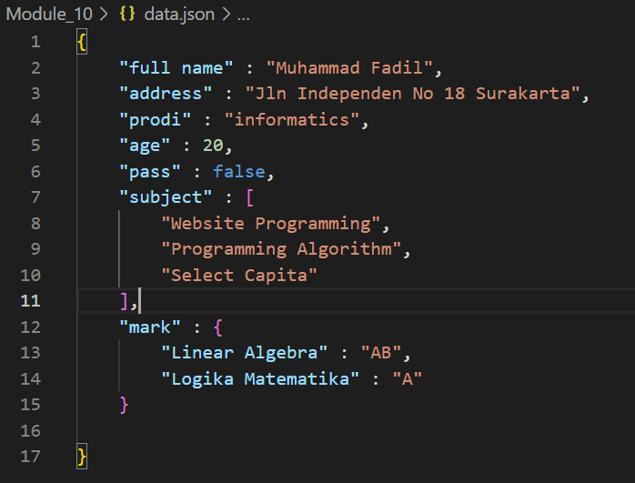

Picture 1.1 The Code.

(Explanation)

Muhammad Fadil is a 20-year-old student majoring in Informatics, living at Jln Independen No 18 Surakarta. He has not graduated yet (pass: false) and is currently studying subjects like Website Programming, Programming Algorithm, and Select Capita. His academic grades include AB in Linear Algebra and A in Mathematical Logic.

(Screenshot Output)

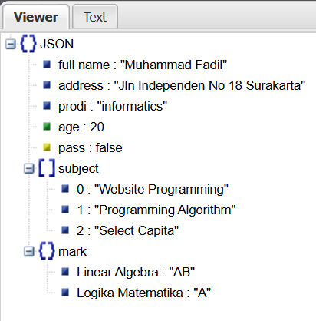

Picture 1.2 The Output.

1. **Experiment 2 (JSON file with array data type)**

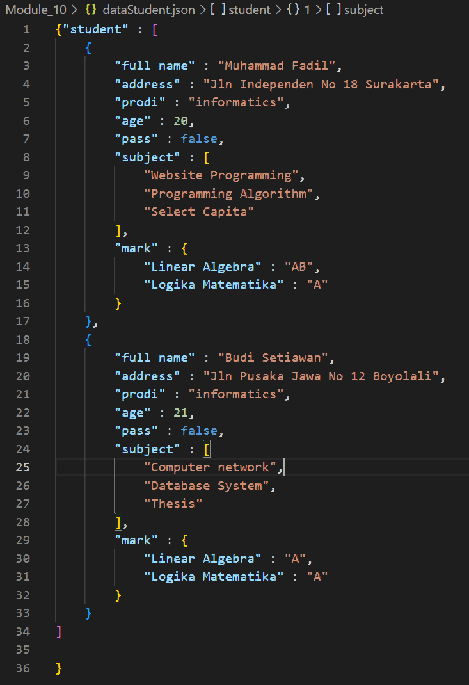

Picture 2.1 the code.

(Explanation)

Muhammad Fadil is a 20-year-old Informatics student living at Jln Independen No 18 Surakarta. He is currently studying subjects like Website Programming, Programming Algorithm, and Select Capita, and has received AB in Linear Algebra and A in Mathematical Logic. Meanwhile, Budi Setiawan, a 21-year-old Informatics student from Jln Pusaka Jawa No 12 Boyolali, is taking Computer Network, Database System, and Thesis, and has obtained A in both Linear Algebra and Mathematical Logic.

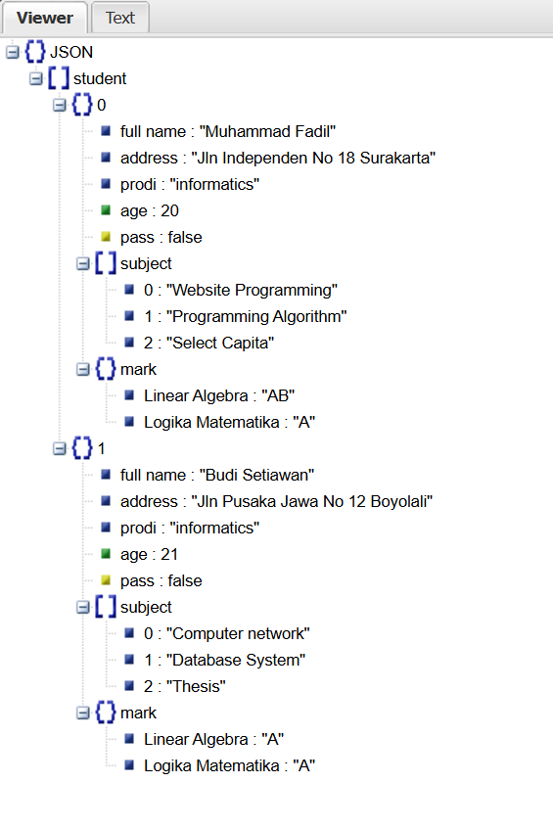

Picture 2.2 the results

1. **Attempt 3 (Search for external JSON)**

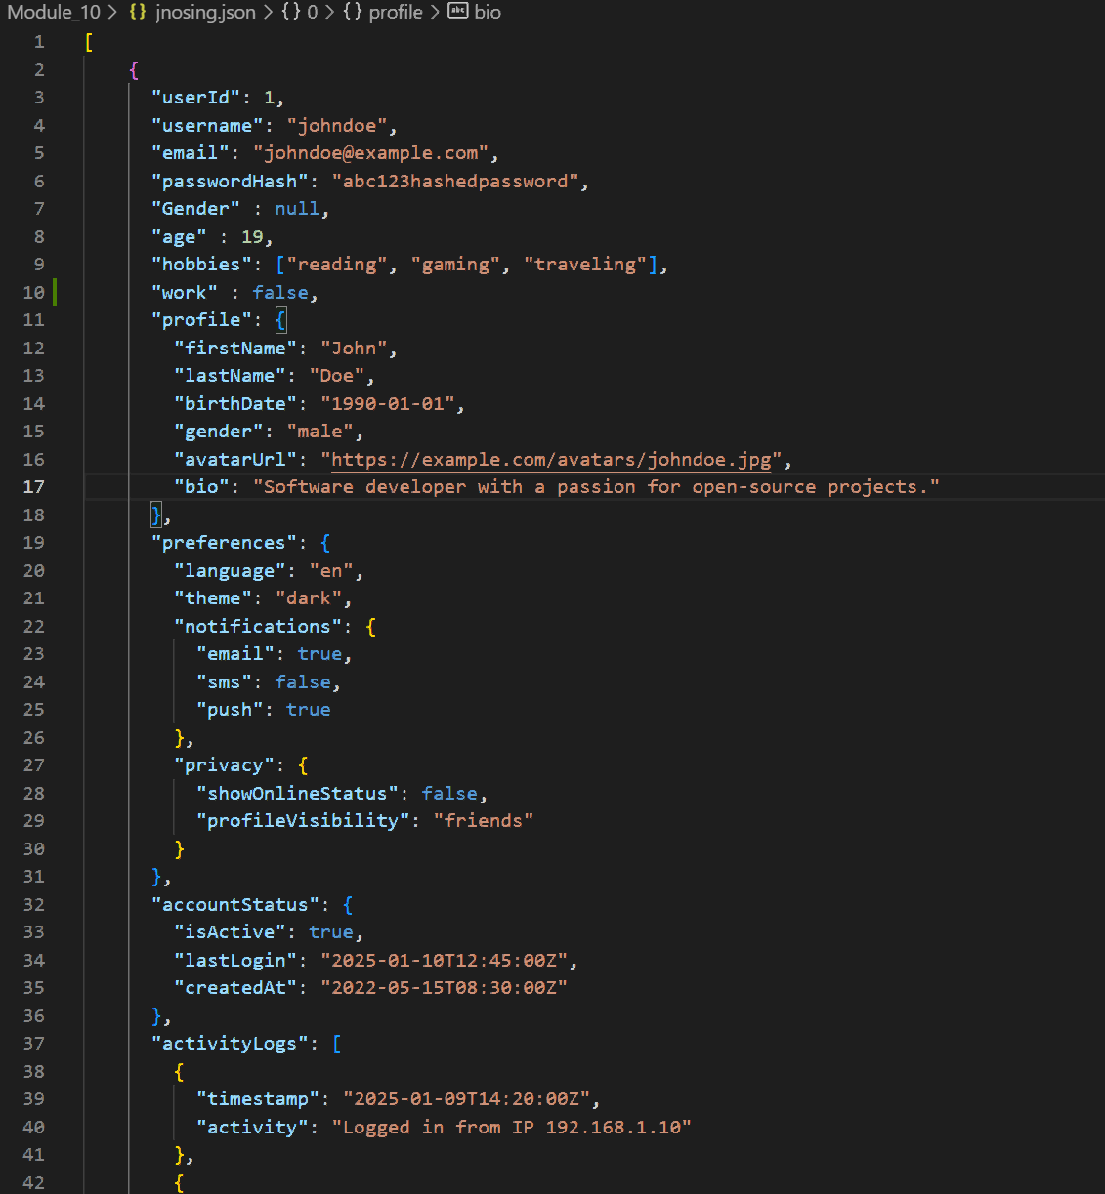

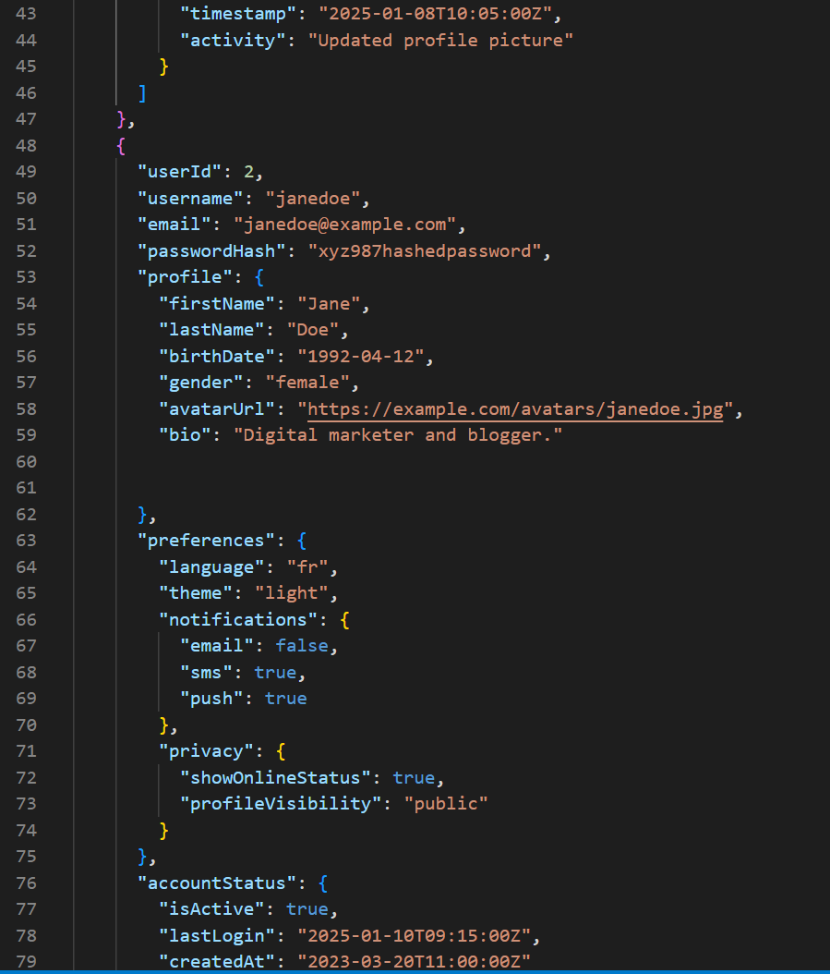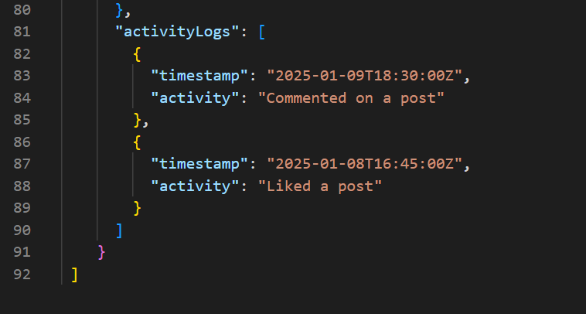

Picture 3.1 the code.

(Explanation)

John Doe, a 19-year-old software developer, enjoys reading, gaming, and traveling, and prefers a dark theme for his account while keeping his online status hidden. His latest activities include logging in from an IP address and updating his profile picture, and his account has been active since May 15, 2022. Meanwhile, Jane Doe, a digital marketer and blogger, speaks French, prefers a light theme, keeps her profile visibility public, and recently commented on and liked a post—her account was created on March 20, 2023.

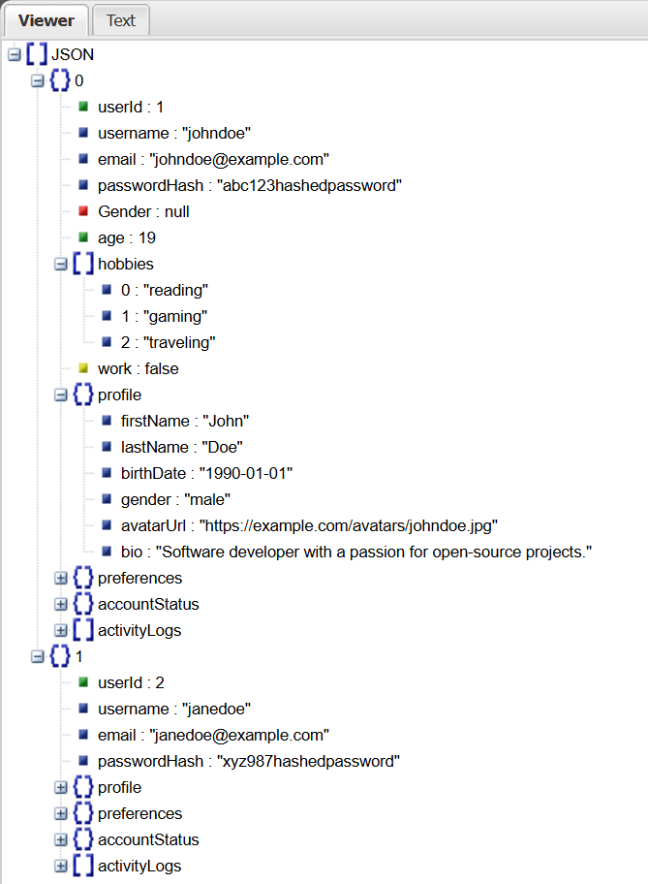

Picture 3.2 the results

1. **Attempt (External JSON)**

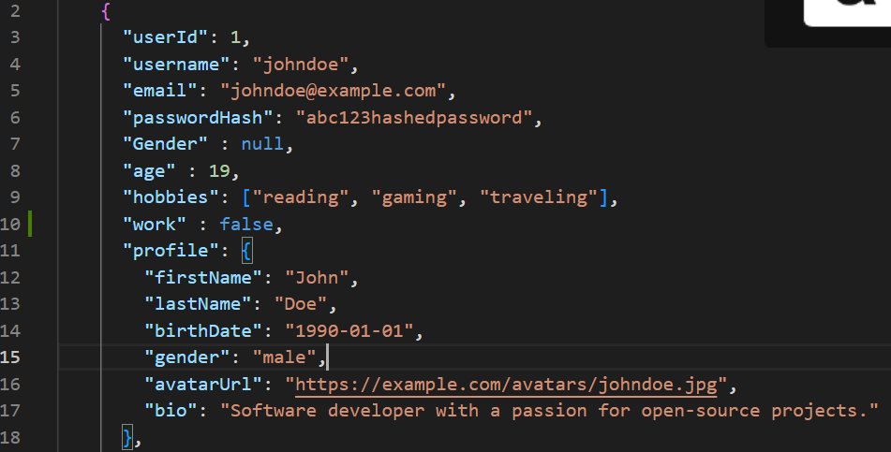

Picture 4.1 the code.

(Explanation)

This JSON structure represents user data, storing information about John Doe, including his personal details, hobbies, work status, and profile information in a structured format.

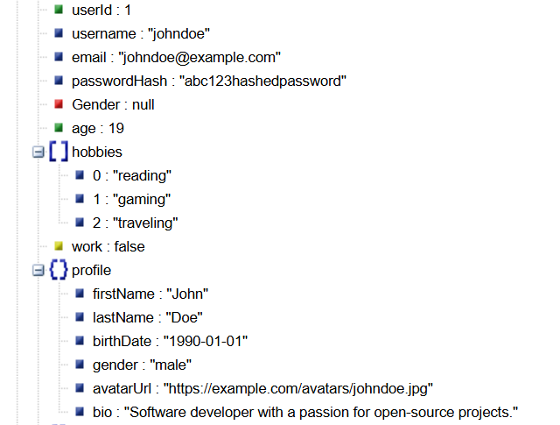

Picture 4.2 the results

**ASSIGNMENT**

1. **Create a JSON file that describes the data reagrding the courses you are taking this semseter. The entries in the JSON file must be complete, for example courses name, number of credits, class schedule, teaching lecturer, courses material chapters, etc (*the more complete the better, and the better the score you will get).**

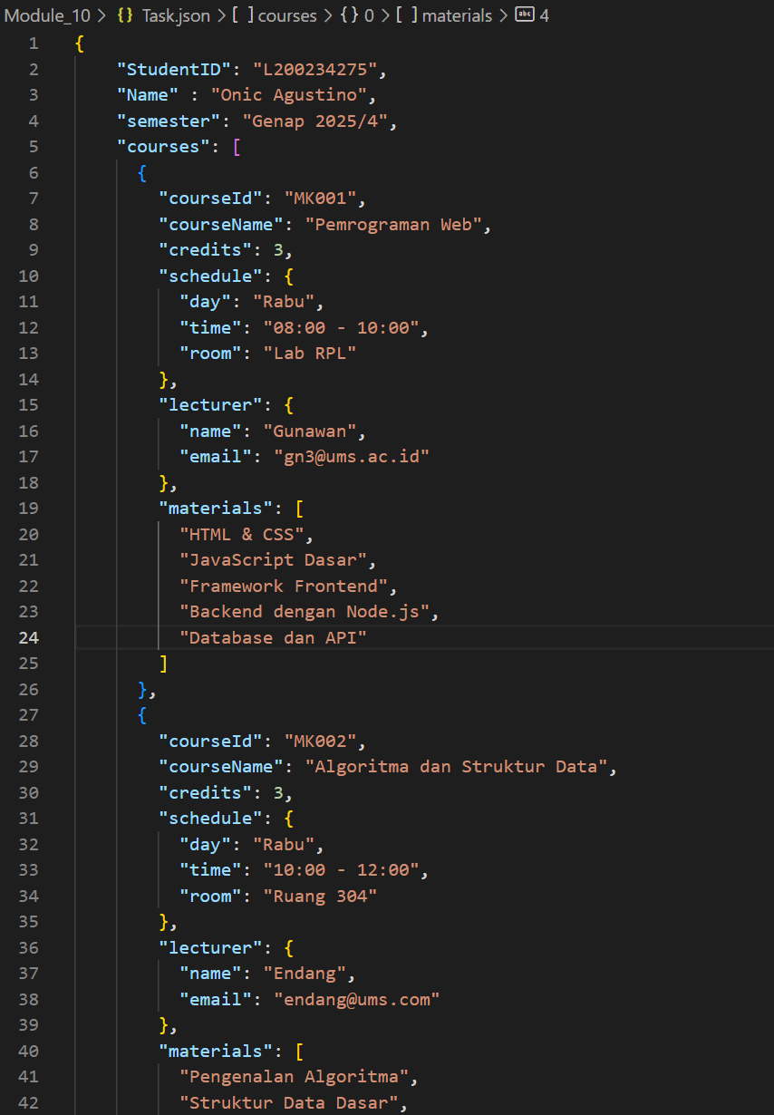

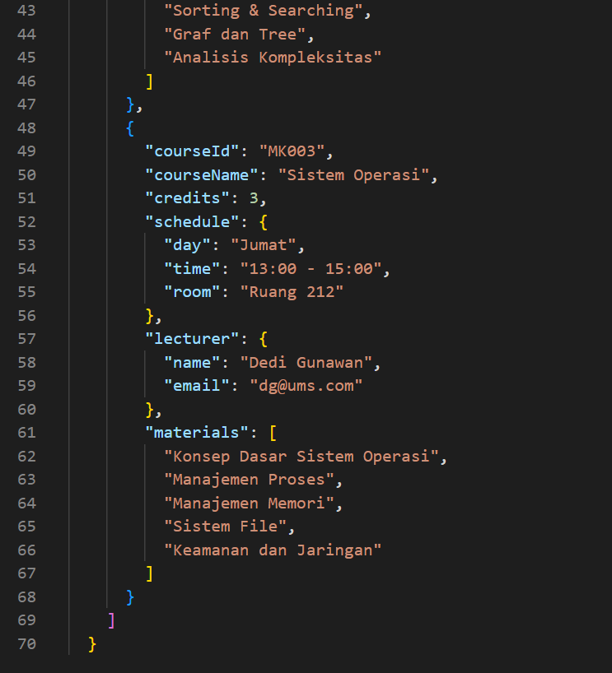

Picture 1.1 tak the code.

(Explanation)

Onic Agustino is a student with ID L200234275, enrolled in the even semester of 2025, taking three courses. His subjects include Web Programming, Algorithms & Data Structures, and Operating Systems, each with assigned lecturers, schedules, and study materials. The structured data helps manage academic details efficiently in educational systems.

(Screenshot Output)

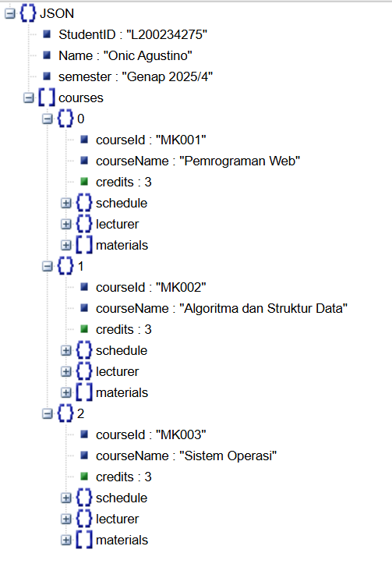

Picture 1.2 task results